
Business Question and Visualization Report

Date | 02 November 2026
Team ID | NA
Project Name | Electric Vehicle Market Performance & Insights
Maximum Marks | 5 Marks

Visualization development refers to the process of creating graphical representations of data to facilitate understanding, analysis, and decision-making. The goal is to transform complex datasets into visual formats that are easy to interpret, enabling users to gain insights and make informed decisions. Visualization development involves selecting appropriate visual elements, designing layouts, and using interactive features to enhance the user experience. This process is commonly associated with data visualization tools and platforms, and it plays a crucial role in business intelligence, analytics, and reporting
Business Questions and Visualisation
The process involves defining specific business questions to guide the creation of meaningful and actionable visualizations in Tableau. Well-framed questions help in identifying key metrics, selecting relevant data, and building visualisation that provide insights.
Business questions answered by my EV Specs & Sales Explorer workbook:
1. What do the headline specifications of the EV market look like?
  - Visualization: KPI text table – 6 measures – sheet “EV Specs Overview”.
  - Scenario(s): 1, 2, 3
  - Insight: The dataset covers 17,980 EV models. On average an EV costs 64,921 USD, reaches 151.8 km/h, has a 3.98-star safety rating, keeps 53.0% of its value after 3 years and comes with a 5.0-year warranty.
  - Screenshot:
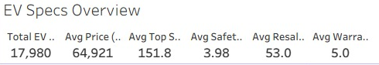

2. Which use cases drive EV sales?
  - Visualization: Horizontal bar chart – SUM(Annual Sales Units) by Recommended Use Case, sorted – sheet “Annual Sales by Use Case”.
  - Scenario(s): 1
  - Insight: Family Daily Use is the largest use case with 620.5 M units (about 40% of sales), followed by Urban Commute (425.6 M) and Highway / Long-Distance (264.2 M). Commercial Delivery (25.9 M) and Public Transport (10.4 M) are small niches.
  - Screenshot:
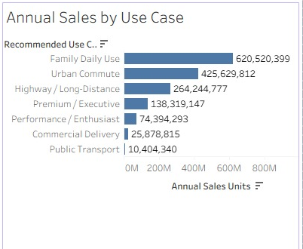

3. How does the average price change between vehicle categories?
  - Visualization: Horizontal bar chart – AVG(Price USD) by Category, colour by price – sheet “Average Price by Vehicle Category”.
  - Scenario(s): 1, 2
  - Insight: Electric Buses are the most expensive (274,543 USD), followed by Electric Trucks (167,749 USD) and Sports Cars (163,593 USD). Two-Wheeler Scooters cost only 2,555 USD – about 100 times less than a bus.
  - Screenshot:
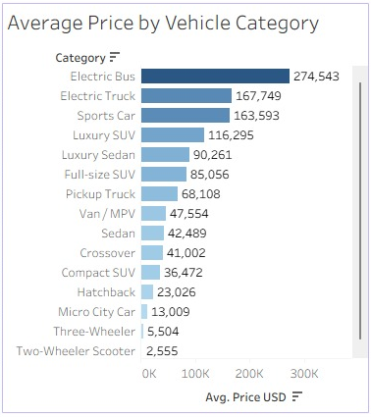

4. Which drivetrains are used in each vehicle category?
  - Visualization: Stacked bar chart – COUNT(Vehicle ID) by Category, colour by Drivetrain – sheet “Drivetrain Mix by Category”.
  - Scenario(s): 2
  - Insight: Overall the mix is balanced (RWD 69,076, FWD 68,455, AWD 62,468 vehicles). AWD dominates Luxury SUVs, Full-size SUVs, Pickup Trucks and Sports Cars (about 65% each), while FWD and RWD lead in everyday cars, two- and three-wheelers.
  - Screenshot:


5. Does battery chemistry change customer satisfaction?
  - Visualization: Bar chart – AVG(Customer Rating) by Battery Type – sheet “Customer Rating by Battery Type”.
  - Scenario(s): 3
  - Insight: Ratings are almost identical for every battery type – from 4.085 (Sodium-Ion) to 4.096 (Solid-State) out of 5. Battery chemistry does not change how satisfied customers are.
  - Screenshot:
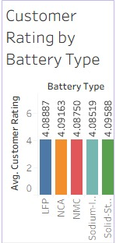

6. Which manufacturing countries produce the most-sold EVs?
  - Visualization: Horizontal bar chart – SUM(Annual Sales Units) by Manufacturing Country, sorted – sheet “Annual Sales by Manufacturing Country”.
  - Scenario(s): 2
  - Insight: EVs built in India (160.0 M units) and China (159.4 M) sell the most, followed by Vietnam (158.1 M) and the UK (157.6 M). Japan is lowest (149.1 M). Every country has about 10% of sales, so production is evenly spread.
  - Screenshot:
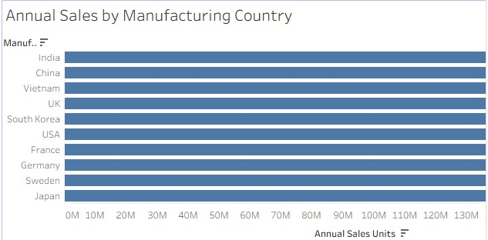

7. How common are self-driving features?
  - Visualization: Pie chart – COUNT(Vehicle ID) by Autonomy Level (0–5) – sheet “Autonomy Level Distribution”.
  - Scenario(s): 1, 3
  - Insight: Level 0 (no automation) is the largest single group at 22.5% of vehicles. Levels 1, 2 and 3 have about 16.5–16.8% each, and Levels 4 and 5 about 13.7% each – so 27.5% of EVs already offer high automation.
  - Screenshot:


8. Has driving range changed over model years, and does drivetrain matter?
  - Visualization: Line chart – AVG(Range km) by Model Year, one line per Drivetrain – sheet “Average Range Trend by Model Year”.
  - Scenario(s): 1, 3
  - Insight: Range stays flat from 2018 to 2026. AWD vehicles travel about 359–364 km on average, around 55 km more than FWD and RWD vehicles (about 305–311 km).
  - Screenshot:


9. How are acceleration and top speed related across categories?
  - Visualization: Scatter plot – AVG(Acceleration 0-100 sec) vs AVG(Top Speed kmph) by Category – sheet “Top Speed vs Acceleration”.
  - Scenario(s): 1, 2
  - Insight: Faster-accelerating categories also reach higher top speeds (correlation −0.62). Sports Cars lead with 279.9 km/h and 3.2 s to 100 km/h, while Electric Buses reach 85 km/h and need 22.4 s.
  - Screenshot:


Total: 9 business questions and visualisations.

